PROJECT PLAN

Prototype for Automated Carton Cycle Counting

Using Computer Vision and Drones

Murtaza Ali Khokhar

[*murtaza.khokhar@ebm.com.pk*](mailto:murtaza.khokhar@ebm.com.pk)

# Project Overview

This project aims to develop a prototype for an automated carton cycle counting system at EBM’s master carton storage facility at Port Qasim. The system will utilize drones equipped with computer vision (CV) technology to perform cycle counts of biscuit cartons. The goal is to enhance inventory accuracy, reduce manual labor, and improve overall efficiency in warehouse operations.

Manual cycle counting in large warehouses is often labor-intensive, time-consuming, and prone to human error. These challenges are particularly significant in a high-volume environment like EBM’s warehouse, where 2 million units of cartons are stored and moved regularly. Automating this process using drones and computer vision can significantly improve accuracy, speed, and safety, while also freeing up human resources for other tasks.

The prototype will serve as a proof of concept, demonstrating the feasibility and benefits of using advanced technologies like drones and CV for inventory management. It will lay the groundwork for potential full-scale implementation across the facility .

# Project Objectives

## Primary Objective

Develop and demonstrate a functional prototype of an automated carton cycle counting system using drones and computer vision.

## Secondary Objective

* Assess the accuracy and reliability of the system in a controlled warehouse environment.
* Identify potential challenges and limitations in the deployment of such a system.
* Provide insights and recommendations for further development and scaling.

# Project Timeline & Scope of Work

* **Week 1 - 2**
  + Requirement Analysis & Planning
    - Assess the warehouse layout, focusing on the selected areas for the prototype.
    - Define technical requirements for the drone and computer vision systems.
    - Develop a detailed project plan, including timelines and key milestones.
* **Week 3 – 6**
  + System Design and Prototype Development
    - Design the system architecture, focusing on drone navigation, computer vision algorithms, and data processing.
    - Develop and configure drones with the necessary hardware for navigation and image capture.
    - Implement computer vision algorithms for object detection, carton counting, and error correction.
    - Conduct initial tests in a controlled environment to refine the system.
* **Week 7-10**
  + Pilot Testing and Evaluation
    - Deploy the prototype in a selected section of the warehouse.
    - Conduct cycle counts and compare results with manual counts for accuracy verification.
    - Collect data on system performance, including accuracy, efficiency, and any operational challenges encountered.
* **Week 11-12**
  + Analysis, Refinement, and Reporting
    - Analyze the results from the pilot testing phase, focusing on the system’s accuracy and efficiency.
    - Refine the system based on feedback and observed performance issues.
    - Prepare a comprehensive report detailing the prototype’s performance, challenges faced, and recommendations for further development.

# Deliverables

* A functional prototype of the automated carton cycle counting system using drones and computer vision.
* A detailed report on the prototype's performance, including accuracy metrics, operational efficiency, and identified challenges.
* Documentation of the system architecture, computer vision algorithms, and integration protocols used.
* Recommendations for next steps and potential improvements for scaling the system.

# Constraints

* The **resolution of the camera is dependent** on the available components, whether it being the camera attached to the drone or any external component attached to it.
* The **flight path, height and duration of the drone are not set** and are not expected to be of ready-to-use standard.
* The lighting needed for favorable images might need to be tested.
* The **accuracy** of the model deployed is expected to be in the **range of 70-90%**

# System Flow

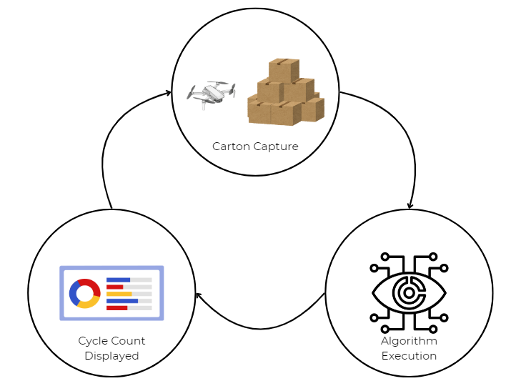

# Design Alternatives: Carton Capture

## Overhead Cameras

The initial design alternative proposed was to set up roof-hanging cameras along each rack of the warehouse. This would enable a clear field of view and allow clearer pictures to be taken of the cartons, however an issue arises regarding cartons placed at a lower height.

A solution proposed for this issue was to have height adjustable capabilities given to the camera stand however that would not be feasible for the length required and the safety hazard that would become. The design fails to address this concern and hence was not considered.

## Drone With External Camera

The second design alternative proposed was to equip an off-the-shelf drone with an external camera using electronic components and microcontrollers. Although the design promised cost-effective and efficient working to achieve the task, an appropriate drone which fulfills all basic criteria has not been found in the market after a brief market research, major concerns regarding flight stability and battery life were pointed out.

# Design Chosen: Carton Capture

## Camera Equipped Drone

The final design alternative proposed is of using a drone already equipped with a camera. This design excludes any tinkering with the camera specifications as it would be an off-the-shelf product. The only consideration would be of how the snapshots collected by the drone camera will be transferred to the computer responsible for algorithm execution. The following are possible case scenarios for this data transfer:

### Wireless Transfer

The snapshots can be collected from the drone via wireless connection, however that is dependent on the drone having the capability to do so. It would also be very dependent on connectivity strength, distance and method (Bluetooth, Wi-Fi).

### Storage Medium Exchange

The snapshots can be collected manually by the drone operator by collecting the storage medium the drone stores the data on (SD Card, USB etc.) and transferring the snapshots onto the computer.

## Drone Specifications

The drone to be procured for the prototype must abide by the following estimate criteria:

#### Equipped Camera

The camera being used with the drone must be of a substantial resolution. A camera with a resolution of **5 MP to 8 MP** should suffice. This will allow identification of carton shapes, sizes, and possibly large labels or markings. If working with video the drone must have at least a **1080 @ 30 fps resolution** for optimal performance.

#### Flight Duration

The flight duration will vary according to the stock needed to be counted, however pertaining to the overall size of the warehouse and the rough estimate of 2 million cartons inventory, the drone must assure a **30-minute flight duration** to be of feasible use.

#### Flight Maneuverability

Due to the enclosed nature of the warehouse, the drone must be of dimensions suitable for its flight environment. Ideal dimensions range around **250x400x80 mm (*LxWxH*)**.

#### Flight Range

The range from where the pilot can operate the drone must be of substantial distance given the size of the warehouse. Rough estimates give a range of **1-1.5 km** transmitter-to-receiver distance.

#### Flight Speed

There is no such constraint for flight speed however keeping in mind safety hazards from workers below the flight path, an ideal speed range is **15-20 m/s**.

### Recommendation:

## **DJI Mini 3**

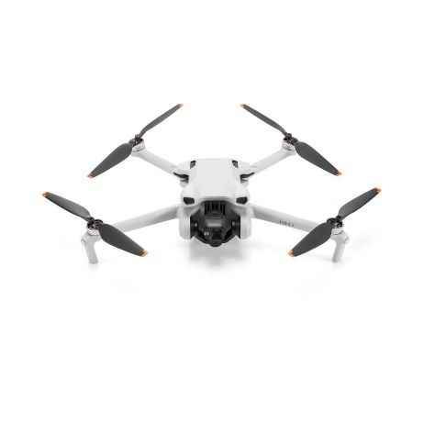

The cost of this drone ranges around **PKR 150,000 – 225,000/-**

Details can be found [here](https://www.w3shopping.com/products/dji-mini-3-fly-more-combo-price-pakistan?pr_prod_strat=e5_desc&pr_rec_id=3d7e6164d&pr_rec_pid=7950520451284&pr_ref_pid=5989464211624&pr_seq=uniform&variant=43877113135316) regarding purchasing and [here](https://dofly.com.pk/dji-mini-3-specs/) regarding more technical specifications.

# Design Alternatives: Algorithm Execution

## Pre-Trained YOLOv7-9 Models

The first design alternative for the algorithm execution module of the project is to call a pre-trained CNN model using a python libraries’ (YOLOv7-9) and feed it our captured carton snapshots. The challenge with this approach is finding a suitable and accurate model on relevant platforms and extensive testing of it to ensure it works.

## Training Own CNN Model

The second alternative involves producing our own Convolutional Neural Network by training it with a pre-built annotated dataset available on relevant platforms. This design approach provides leverage in the form that we can use own images to train the model for exceptional accuracy but will require hardware resources and time to complete training and testing.

# Design Chosen: Algorithm Execution

## Training Semi-Altered Model via RoboFlow

*To be written*

# Functional Requirements

**1. Avoiding Double Counting**

Ensuring that each carton is counted only once.

**2. Detecting and Handling Obstructed Cartons**

Cartons that are partially obstructed or hidden behind other objects may be difficult to detect or count accurately.

**3. Distinguishing Similar-Looking Cartons**

Cartons that look very similar (e.g., identical packaging) might be mistakenly counted as duplicates or missed altogether.

**4. Counting Cartons in Varying Lighting Conditions**

Poor or inconsistent lighting in different areas of the warehouse might affect the accuracy of the drone’s camera and computer vision system.

**5. Dealing with Moving Cartons**

Cartons that are being moved by warehouse workers or machinery during the counting process might lead to incorrect counts.

**6. Handling Different Carton Sizes and Shapes**

Warehouses often store cartons of varying sizes and shapes, which might be challenging for standard computer vision algorithms to count accurately.

**7. Recognizing Damaged or Deformed Cartons**

Damaged or deformed cartons might not be recognized by standard image processing algorithms, leading to inaccurate counts.

**8. Integrating with Warehouse Management Systems (WMS)**

The drone and computer vision system must seamlessly integrate with the existing Warehouse Management System (WMS) to update inventory records in real-time.

**10. Managing Battery Life and Coverage**

Drones have limited battery life, which might affect their ability to cover large warehouse areas in a single flight.